Champagne Vignon Père & Fils
Grand Cru Grower – Verzenay, Montagne de Reims, Champagne
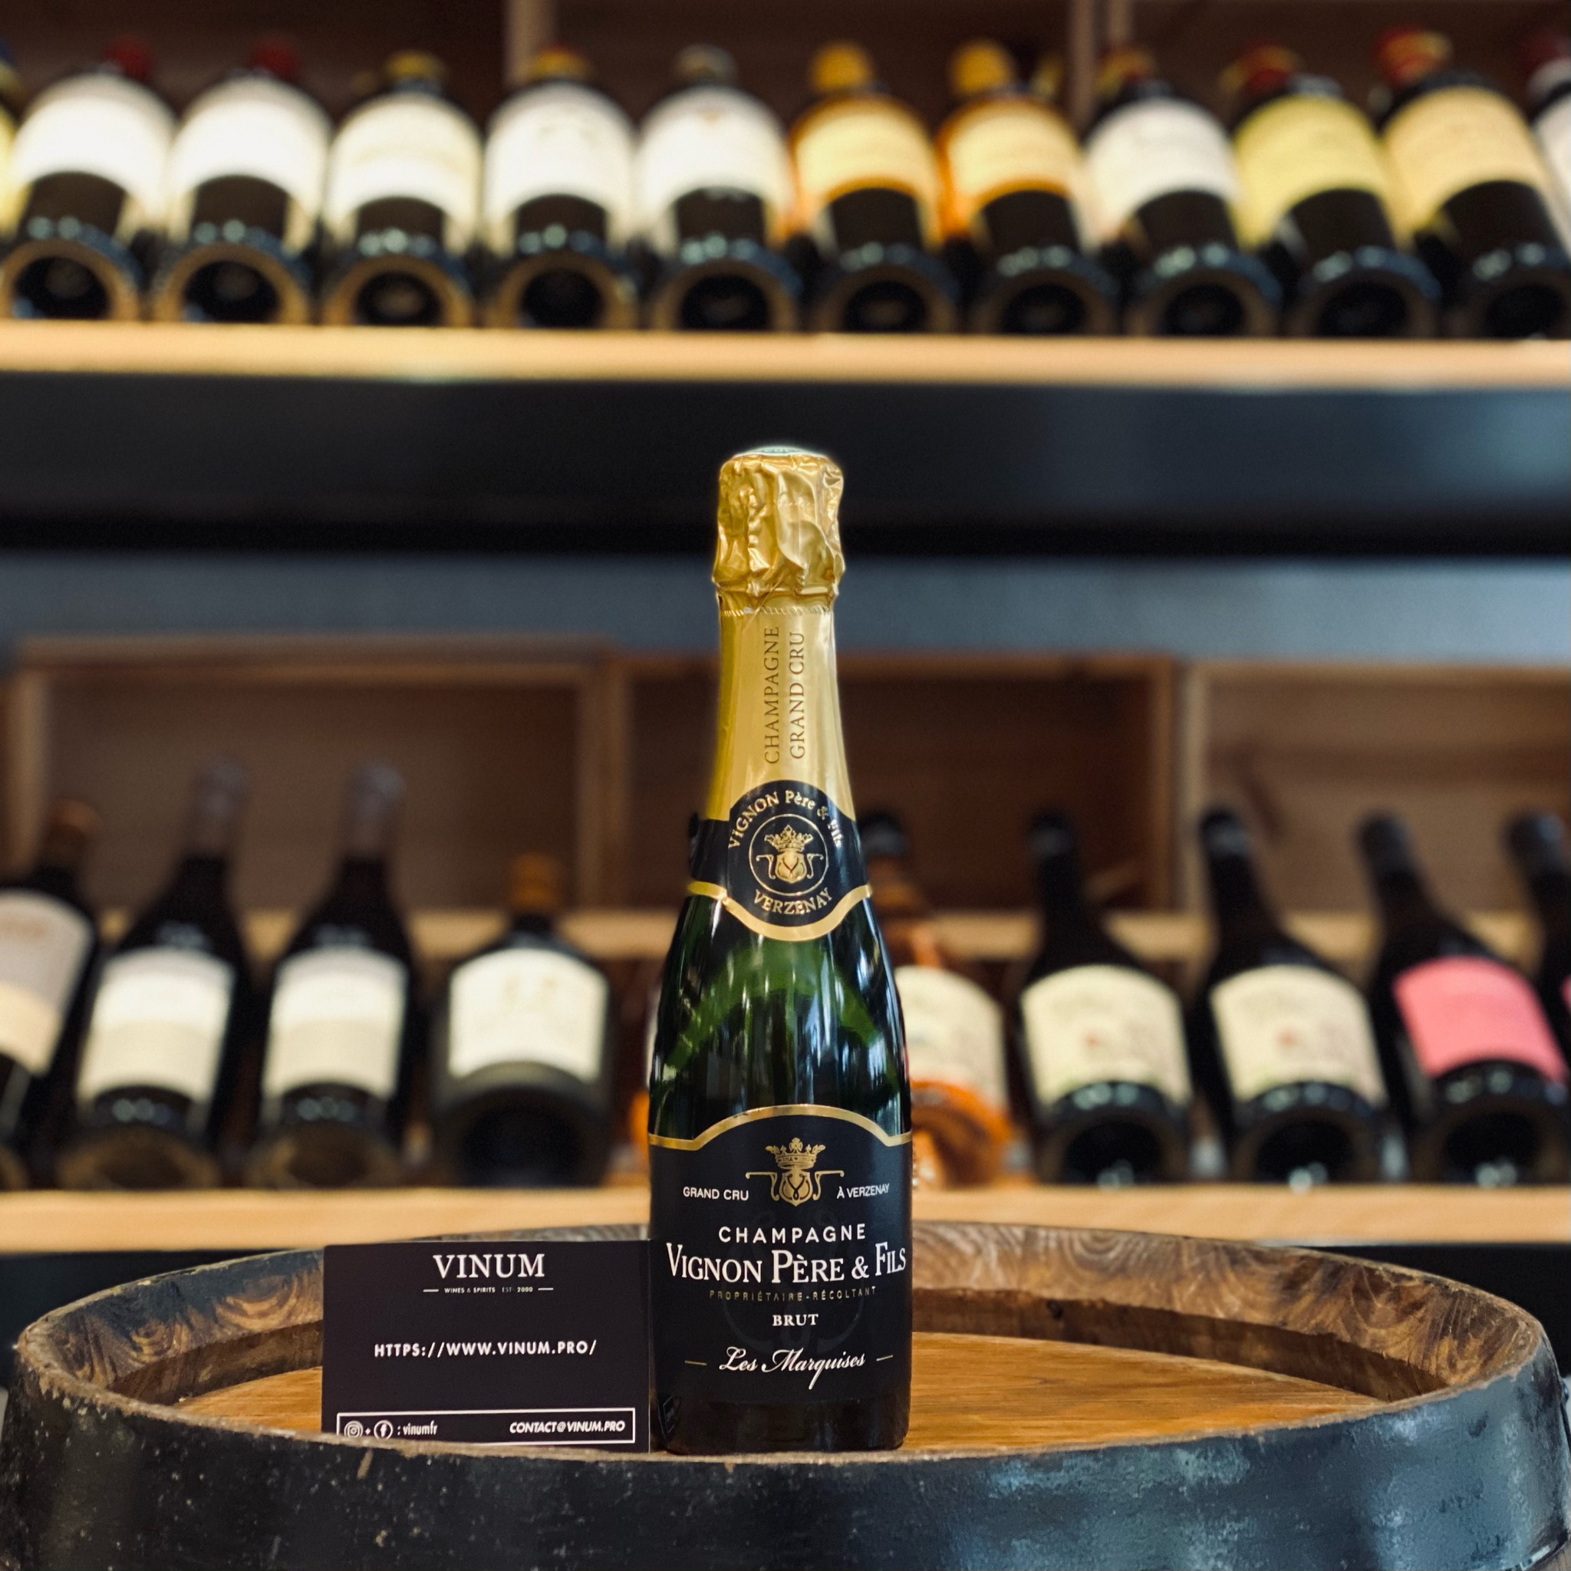

Introduction
Champagne Vignon Père & Fils is a small grower-producer located in the historic Grand Cru village of Verzenay in the Montagne de Reims, one of the most prestigious subregions of Champagne. The estate focuses on limited-production wines that express the character of their terroir through traditional Champagne production methods and careful vineyard management.
Unlike large Champagne houses that source grapes from many villages, grower-producers such as Vignon Père & Fils craft wines primarily from their own vineyards. This approach allows a deeper connection between the wine and the land, highlighting the influence of soil, climate and vine age.

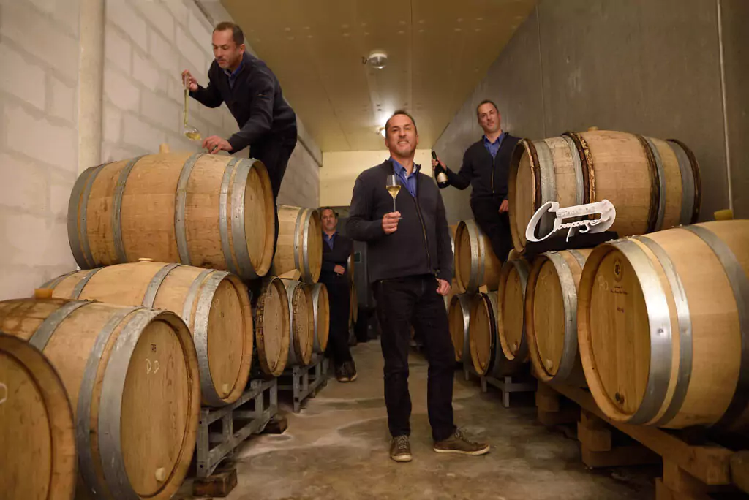

Terroir and Vineyard Location
The vineyards are located primarily in Verzenay and Verzy, both classified as Grand Cru villages in the Montagne de Reims. These vineyards sit on chalk-rich soils that provide excellent drainage and reflect sunlight back to the vines, contributing to the ripeness and balance of the grapes.
The Montagne de Reims is particularly known for its Pinot Noir vineyards, producing wines with structure, depth and elegance. Chardonnay grown on these soils adds freshness, minerality and aromatic complexity.

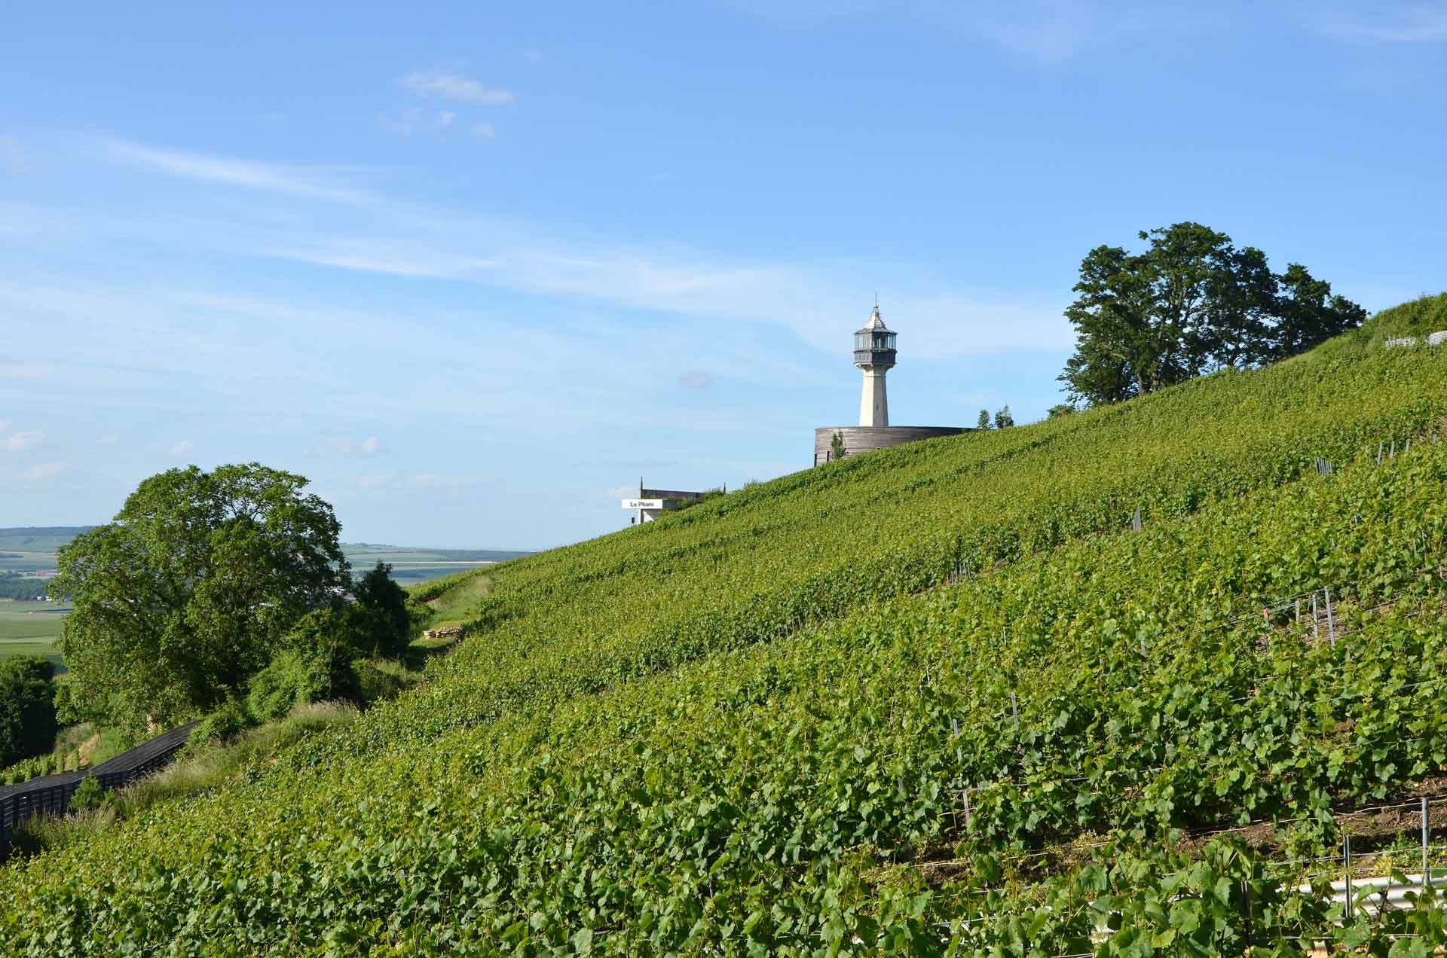

Winemaking Philosophy
The philosophy of Vignon Père & Fils centers around traditional winemaking practices that respect the integrity of the grapes and the identity of the vineyard. Fermentation is typically carried out with natural yeasts, and many cuvées are aged in oak barrels to enhance texture and complexity.
The wines are produced with minimal intervention, often avoiding fining or filtration in order to preserve the purity of the fruit and the expression of the terroir. Each plot may be vinified separately to highlight the subtle differences between parcels.

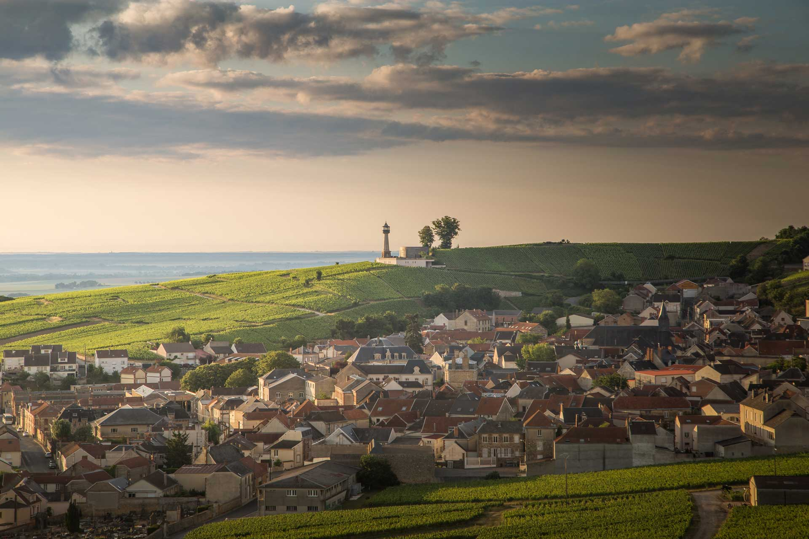

Key Characteristics of the Estate
- Grand Cru vineyards located in Verzenay and Verzy
- Focus on Pinot Noir and Chardonnay grown on chalk soils
- Use of natural yeast fermentation
- Oak barrel aging for certain cuvées
- Minimal intervention winemaking approach
- Limited production wines with strong terroir identity

Wine Portfolio Overview
The portfolio of Vignon Père & Fils includes a diverse range of Champagnes showcasing the character of their vineyards. The wines include Blanc de Noirs, Blanc de Blancs, Rosé Champagne and prestige vintage cuvées, many produced in limited quantities.
- Les Marquises Brut Grand Cru
- Les Marquises Extra Brut
- Réserve des Marquises 2019
- Potences-Rochelles Blanc de Blancs
- Les Espérances Blanc de Noirs
- Les Vignes Goisses Rosé
- Vol au Vent 2018
- L’Etoile de Saint Basle (Coteaux Champenois red wine)

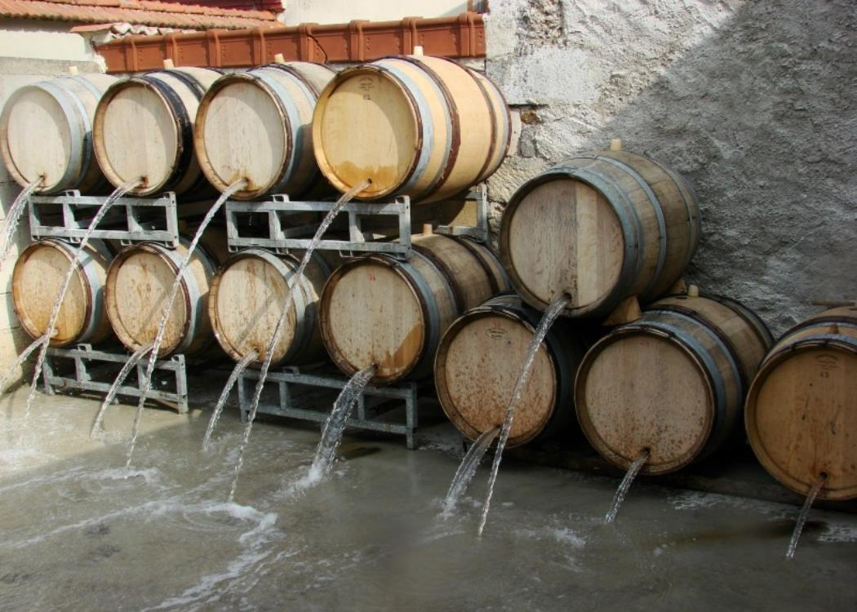

Market Positioning
Due to the limited production and focus on Grand Cru terroir, the wines of Vignon Père & Fils are particularly well suited for high-end gastronomy, wine bars and specialized retailers. The balance of fruit expression, minerality and structure makes these wines attractive to sommeliers and Champagne enthusiasts seeking distinctive grower Champagnes.

Conclusion
Champagne Vignon Père & Fils represents the spirit of modern grower Champagne: wines that prioritize authenticity, vineyard identity and craftsmanship. With their Grand Cru origins in Verzenay and Verzy and their commitment to traditional methods, the estate produces Champagnes that combine elegance, depth and terroir-driven character.

